ArduLink Shiled is a platform that bring many arduino project to life quickly without having to do a lot breadboard connections.

ArduLink enables modular plug and play approach for enthusiast to design and develop applications as suits their end goal. It is a tool that provides ability to develop application faster without worrying about hardware components.

General Block Diagram View

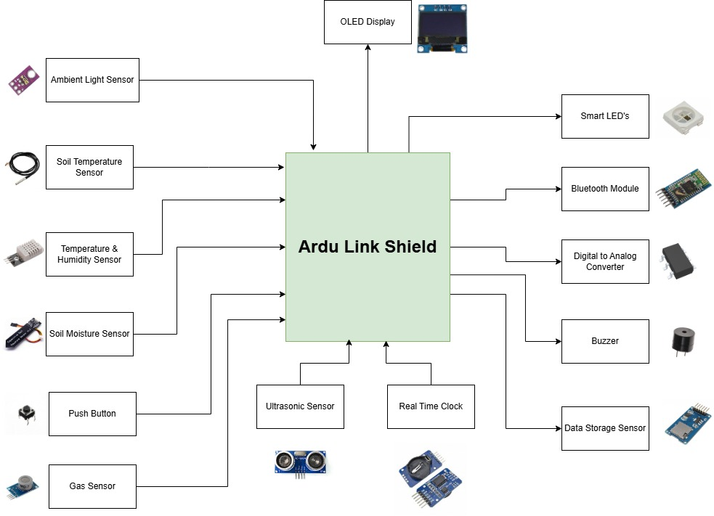

Shield Picture

Shield picture with arduino uno as base

Shield picture with arduino mega as base

Simpliying projects using ArduLink Shield

Project 1: LED Pattern

Project 2: Play Buzzer Tone

Project 3: Control LED using Push Button

Project 4: Ambient Light

Project 5: Ambient Temperature and Humidity Monitoring

Project 6: Soil Moisture Monitoring

Project 7: Gas Monitoring

Project 8: Temperature Monitoring - OneWire

Project 9: Real Time Clock

Project 10: Measurement Ruler

Project 11: Disco Dancer

Project 12: Face Animation using OLED Display

Project 13: SD Card Data Logger

Project 14: DAC Signal Generator

Project 15: Temperature and Humidity OLED Gage

Project 16: Bluetooth LED Control

Project 17: Weather Station

Project 18: Agricultural Monitoring

You can do many more project using these modular approach of having plug and play extensible system.

Feature and Specifications:

Add Picture showing the capabilties: - Point and show each sensors

Show Form Factor: Dimensions

Show pin out diagrams - What sensor is connected to which pin on Uno

Attach datasheet links - By uploading it to github - Make a new github page or account?

* Inputs:
  + Temperature & Humidity: DHT11/22/21 - [DHT11 Humidity & Temperature Sensor](https://www.mouser.com/datasheet/2/758/DHT11-Technical-Data-Sheet-Translated-Version-1143054.pdf), [Microsoft Word - HM2301-Digital-output-humidity-and-temperature-sensor.doc](https://mikroshop.ch/pdf/DHT21.pdf), [DHT22.pdf](https://www.sparkfun.com/datasheets/Sensors/Temperature/DHT22.pdf)
    - Operating Voltage: 3.5V to 5.5V
    - Operating current: 0.3mA (measuring) 60uA (standby)
    - Output: Serial data
    - Temperature Range: -40°C to 80°C
    - Humidity Range: 0% to 100%
    - Resolution: Temperature and Humidity both are 16-bit
    - Accuracy: ±0.5°C and ±1%
  + OneWire Temperature: DS18B20 - [DS18B20 - Programmable Resolution 1-Wire Digital Thermometer](https://www.analog.com/media/en/technical-documentation/data-sheets/DS18B20.pdf)
    - Unique 1-Wire® Interface Requires Only One Port Pin for Communication
    - Reduce Component Count with Integrated Temperature Sensor and EEPROM
    - Measures Temperatures from -55°C to +125°C (-67°F to +257°F)
    - ±0.5°C Accuracy from -10°C to +85°C
    - Programmable Resolution from 9 Bits to 12 Bits
  + Light: TEMP6000 - [temt6000.pdf](https://www.vishay.com/docs/81579/temt6000.pdf)
    - High photo sensitivity
    - Adapted to human eye responsivity
    - Angle of half sensitivity:  = ± 60°
    - It is sensitive to visible light much like the human eye
    - Peak sensitivity at 570 nm
* Push Button: SPST 4.5mm SMD Tactile Swtich - [KH-4.5X4.5X4.3H-STM | Shenzhen Kinghelm Elec | Tactile Switches | JLCPCB](https://jlcpcb.com/partdetail/3009620-KH_4_5X4_5X4_3HSTM/C2837550)
  + - Power Rating: MAX 50mA 12V DC
    - Operating Temperature Range: -20 to +70 ℃
    - Storage Temperature Range: -20 to +70 ℃
    - Operating Force: 2.55±0.69 N
  + Ultrasonic Device: HC-SR04 -[HC-SR04](https://cdn.sparkfun.com/datasheets/Sensors/Proximity/HCSR04.pdf)
    - Operating voltage: +5V
    - Theoretical  Measuring Distance: 2cm to 400cm
    - Practical Measuring Distance: 2cm to 80cm
    - Accuracy: 3mm
    - Measuring angle covered: 15°
    - Operating Current: 15mA
    - Operating Frequency: 40Hz
    - Trigger Input Signal 10uS TTL pulse
  + Gas Sensor: MQ7 - [MQ-7.doc](https://www.sparkfun.com/datasheets/Sensors/Biometric/MQ-7.pdf)
    - Operating voltage: +5V
    - Heating time (high): 60 ± 1seconds
    - Heating time (low): 90 ± 1 seconds
    - Operating Temperature Range: -20 to +50 ℃
    - Storage Temperature Range: -20 to +50 ℃
    - Relative humidity: Less than 95% RH
    - Oxygen Concentration: 21% (stand condition) - Min val is over 2%
    - Detecting Range: 20ppm - 2000ppm carbon monoxide
  + Moisture Sensor: SEN0193 -[Microsoft Word - Extruder 50mm Fan](https://media.digikey.com/pdf/Data Sheets/DFRobot PDFs/SEN0193_Web.pdf)
    - Operating Voltage: 3.3V to 5.5 VDC •
    - Operating Current: 5mA
    - Operating Temperature range: -10 to +50 ℃
  + Real Time Clock: DS3231 - [DS3231.pdf](https://www.analog.com/media/en/technical-documentation/data-sheets/DS3231.pdf)
    - Highly Accurate RTC Completely Manages All Timekeeping Functions
    - Accuracy ±2ppm from 0°C to +40°C
    - Accuracy ±3.5ppm from -40°C to +85°C
    - Digital Temp Sensor Output: ±3°C Accuracy
    - Simple Serial Interface Connects to Most Microcontrollers
    - Fast (400kHz) I2C Interface
    - Low Power Operation Extends Battery-Backup Run Time
    - Operating voltage: 3.3V to 5V
    - Operating Temperature Ranges: Commercial (0°C to +70°C) and Industrial (-40°C to +85°C)
* Outputs:
  + Piezo Buzzer:
    - 80dB external drive
    - Resonance frequency: 4KHz sound
    - Max Input Voltage(Vp-p): 30 3
    - Capacitance at 1000Hz (nF): 12±30% 4
    - Current Consumption (mA): ≤3at4.0KHz SquareWave5Vp-p
    - Operating Temperature(℃): -20 to +80
    - Storage Temperature(℃): -30 to +80
  + RGB LED: WS2812B - [Feature](https://cdn-shop.adafruit.com/datasheets/WS2812B.pdf)
    - Intelligent reverse connect protection
    - Control circuit and RGB chip are integrated in a signle package of 5050
    - Built-in electrics reset circuit and power lost reset circuit
    - Primary color can achieve 256 brightness display, completed 16777216 color full color display, scan frequency not less than 400Hz/s
    - Data at speed of 800Kbps
  + OLED Display: SSD1306 - [SSD1780](https://cdn-shop.adafruit.com/datasheets/SSD1306.pdf)
    - Resolution: 128 X 64 dot matrix panel
    - Operating Voltage: (Vdd = 1.65 to 3.3V for IC Logic) & (7V to 15V for Panel)
    - Maximum source current: 100uA
    - Maximum sink current: 15mA
    - 256 step contrast brightness current control
    - SRAM display buffer
    - I2C Interface
    - Operating Temperature: -40 to +85 ℃
    - Programmable Frame Rate and Multiplexing Ratio
    - Row & Column Re-mapping
  + Digital to Analog Converter: MCP4725 - [12-Bit Digital-to-Analog Converter with EEPROM Memory](https://ww1.microchip.com/downloads/aemDocuments/documents/APID/ProductDocuments/DataSheets/MCP4725-12-Bit-Digital-to-Analog-Converter-with-EEPROM-Memory-DS20002039.pdf)
    - Resolution: 12-Bit
    - OnBoard EEPROM Non-volatile memory
    - I2C Interface: Standard (10oKbps), Fast (400Kbps) & High Speed (3.4Mbps)
    - Operating Temperature: -40 to +125 ℃
    - Low power consumption with fast settling time (6us)
    - Operating voltage: 2.7V to 5.5V
* Connectivity:
  + Bluetooth: HC-05 Module - [HC-05 Datasheet.pdf](https://components101.com/sites/default/files/component_datasheet/HC-05 Datasheet.pdf)
    - Receiver Sensitivity: -80dBm
    - Maximum Transmit Power: ++4dBm
    - UART Interface Speed Support: 9600, 19200, 38400, 57600, 115200, 230400, 460800
    - PIO0 & PIO1 shows LED status - Connect, Disconnect
    - Integrated Antenna with Edge Connector
    - Module Operating Voltage: 1.8V to 5V
    - Range: <100m
    - Operating Current: 30mA
    - Follows IEEE 802.15.1 Standard Protocol Standards
    - Uses Frequency Hopping Spread Spectrum (FHSS)
  + SD Card Module: [Micro-SD-Card-Module-Datasheet.pdf](https://components101.com/sites/default/files/component_datasheet/Micro-SD-Card-Module-Datasheet.pdf), [In-Depth Tutorial to Interface Micro SD Card Module with Arduino](https://lastminuteengineers.com/arduino-micro-sd-card-module-tutorial/)
    - Onboard 3.3V voltaga regulator
    - Standard SPI Interface Support
    - Logic Level Shifter for safe communication between MicroSD card and Microcontroller
    - Operating Voltage: 3.3V to 5.5V
    - Operating Temperature: -10 to +80 ℃
    - SD Card Supported: 2GB, 4GB, 8GB, 16GB & 32GB
* Extensibility
  + Compatible with HC-06 Bluetooth Module (Ensure proper pin connection while plugging into the shield)
  + Compatible with Arduino Uno, Mega, & R4 WiFi
  + Unused IO’s can be further used to create more applications

Add pictures of the sensors used - Done

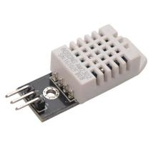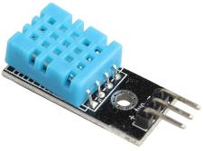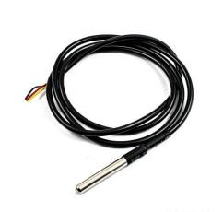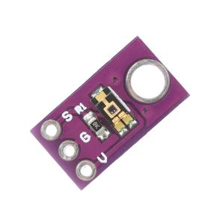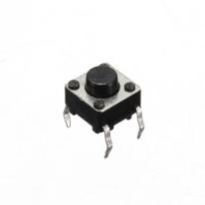

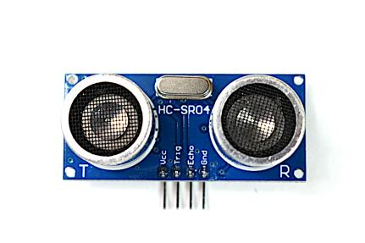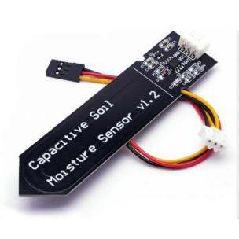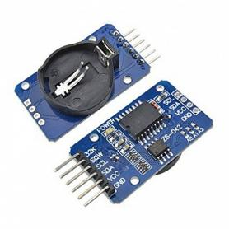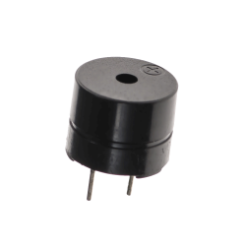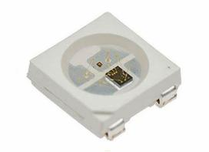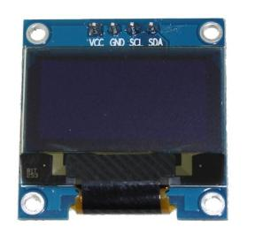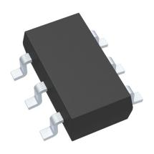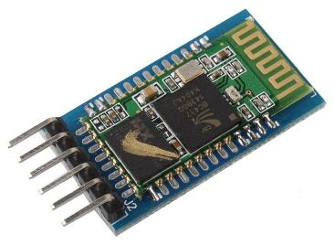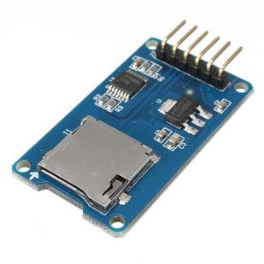

Add Amazon link

Link datasheets whereever necessary - Done

Designed as Open Source

Providing the ability to use the shield to give life to more interesting project

Schematics

Layout

Sample - Github profile with all the information and sample code

Documentation - Show image and pins out

 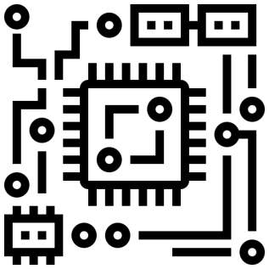 

* What makes this shield interesting is the ability to be extensible and compatible with many integrated development environemnt
  + [Arduino](https://www.arduino.cc/)
  + [Atmel-Studio](https://www.microchip.com/en-us/about/corporate-overview/acquisitions/atmel)
  + [Blynk](https://docs.blynk.io/en/blynk-library-firmware-api/installation/install-blynk-library-in-arduino-ide)
  + [Eclipse](https://playground.arduino.cc/)
  + [ThingSpeak](https://www.mathworks.com/help/thingspeak/examples.html?category=index&exampleproduct=all&newonly=)
  + [Visual Studio](https://marketplace.visualstudio.com/items?itemName=VisualMicro.ArduinoIDEforVisualStudio)
  + [PictoBlox](https://ai.thestempedia.com/docs/pictoblox/arduino-uno-with-pictoblox/)
* Wide Range of Libraries Supported
* Supportes all major operating systems
  + Windows
  + MAC OS

Add photos of all these above stuff to make it look cool - Done



   